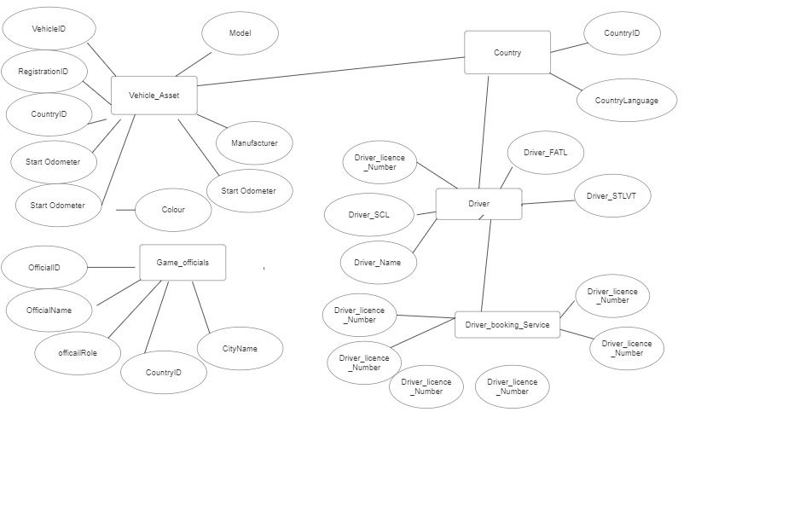**Entity : Vehicle Asset**

Attributes (Vehicle ID ,RegistrationID,

Manufacturer, Model, Current Odometer , PassangerCapicity , Available)

**Entity : County**

Attreibutes(CountryID ,CountryLanguage)

**Entity : Driver**

Attributes(

Driver_LicenceNumber , Driver_Name ,Driver_SCL ,Driver_FATL ,Driver_STLVT)

**Entity : Driver_booking_Service**

Attributes ( Booking_Ref_NO, _LicenceNumber, VehicleID, Official , BookingLocation,Bookingtye,Trip_Start_Date,Trip_End_Date,Start_odometer,

Ondometer)